Name: Class:

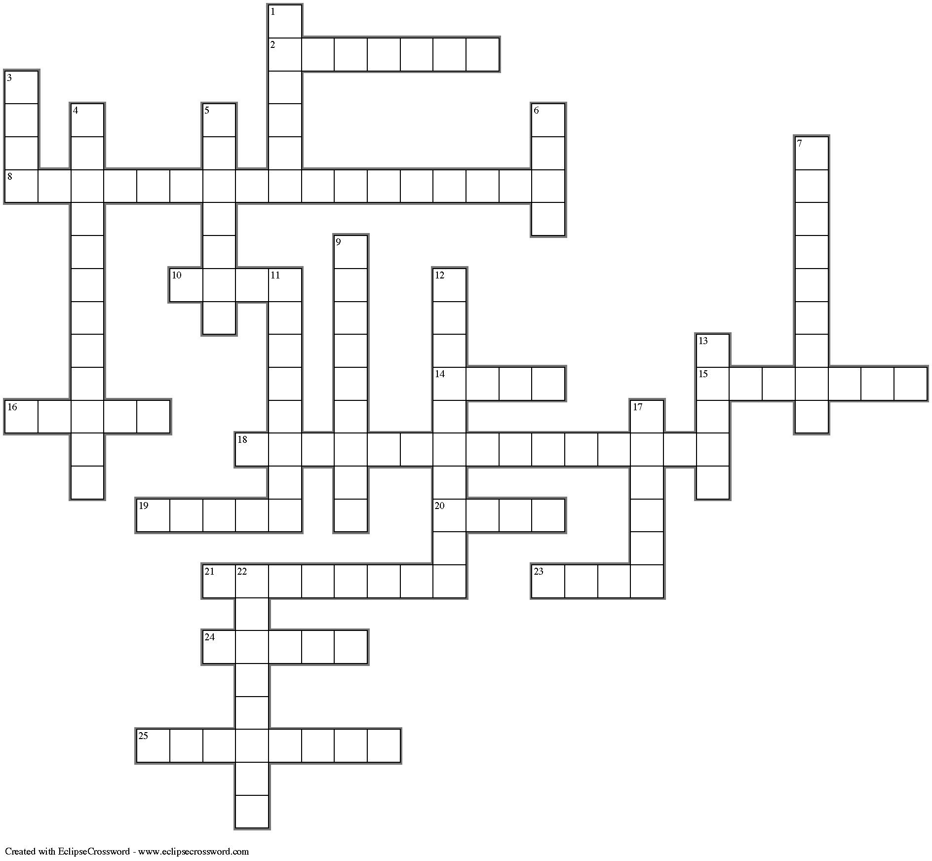
Across
2. Many window cleaners contain this basic substance.
8. The sodium salt of this ion is baking soda.
10. A common name for a hydroxide used to neutralise soil acidity.
14. The taste of an acid.
15. The analgesic chemically known as acetyl salicylic.
16. ______ acid is a mild antiseptic used in ointments for dressing wounds.
18. A caustic chemical used in drain cleaners. (6, 9)
19. ______ acid is found in grapes and apples, particularly unripe ones.
20. Carbonic acid is found naturally in this watery substance.
21. _______ acid is Vitamin C.
23. Many watch batteries have this hydroxide as a reactant.
24. Hydrofluoric acid is used to etch this substance.
25. Produced when hydrochloric acid reacts with iron.

Down
1. ______ acid is found in wine and tea.
3. The chemical formula for the carboxylic acid functional group.
4. ______ acid is the main component of concrete cleaner.
5. A fatty acid with molecular formula of C₁₈H₃₆O₂, found widely in solid fats.
6. Human urine contains this basic substance.
7. _______ acid is the systematic name for the acid present in bee stings.
9. One of the hydroxides commonly used in antacid preparations.
11. ______ acid is an alternative name for the acid in vinegar.
12. ______ acid is an active ingredient in Coca-Cola.
13. One of the products of the reaction between an acid and a metal hydroxide.
17. Lemons and oranges contain ______ acid.
22. ______ acid is found in most car batteries.

